

**Prepared for**:

**Date:**

**Prepared by:** Sumidha Ravindran

Document Name: Lab Manual

**Document Topic: Azure CDN**

**Contributor:**

***Table of Content***

***1 Objective…………………………………………………………………………………….3***

***2 Pre-requisite……………………………………………………………………………….3***

***3 Theory………………………………………………………………………………………..3***

***4 Create Azure Storage Account …………..…….………………………………..4***

***🡪Management Console…………………………………………………………………4***

***5 Creating a CDN connection ………...………….………………………………..8***

1. ***OBJECTIVE***

To create a CDN connection of the Storage account.

1. ***PRE-REQUISITE***

* Account in Azure
* Create Storage Account

1. ***Theory***

***What is CDN?***

A CDN is a network of servers that distributes content from an “origin” server throughout the world by caching content close to where each end user is accessing the internet via a web-enabled device. The content they request is first stored on the origin server and is then replicated and stored elsewhere as needed. By caching content physically close to where a user is and reducing the distance it has to travel, latency is reduced. This process also decreases stress on origin servers by distributing the load geographically across multiple servers.

***How a CDN works?***

To minimize the distance between the visitors and your website’s server, a CDN stores a cached version of its content in multiple geographical locations (a.k.a., points of presence, or PoPs). Each PoP contains a number of caching servers responsible for content delivery to visitors within its proximity.

In essence, CDN puts your content in many places at once, providing superior coverage to your users. For example, when someone in London accesses your US-hosted website, it is done through a local UK PoP. This is much quicker than having the visitor’s requests, and your responses, travel the full width of the Atlantic and back.

***What are the benefits of using a CDN?***

**Improving website load times -** By distributing content closer to website visitors by using a nearby CDN server (among other optimizations), visitors experience faster page loading times. As visitors are more inclined to click away from a slow-loading site, a CDN can reduce bounce rates and increase the amount of time that people spend on the site.

**Reducing bandwidth costs -** Bandwidth consumption costs for website hosting is a primary expense for websites. Through caching and other optimizations, CDNs are able to reduce the amount of data an origin server must provide, thus reducing hosting costs for website owners.

**Increasing content availability and redundancy -** Large amounts of traffic or hardware failures can interrupt normal website function. Thanks to their distributed nature, a CDN can handle more traffic and withstand hardware failure better than many origin servers.

**Improving website security** **-** A CDN may improve security by providing DDoS mitigation, improvements to security certificates, and other optimizations.

1. ***Create Azure Storage Account***

**Step-1**

Now on the search bar search for Storage Account and the click on it.

**Step-2**

Choose your resource group and give a globally unique name to your storage account. Then simply review and create.

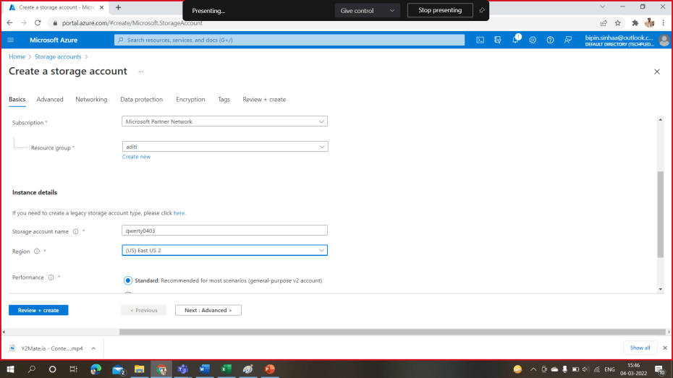

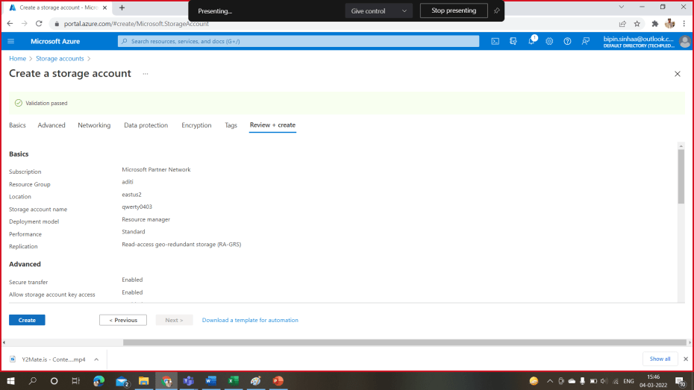

**Step-3**

Now on the left menu bar navigate to Containers. Then Click on Container and create a new container.

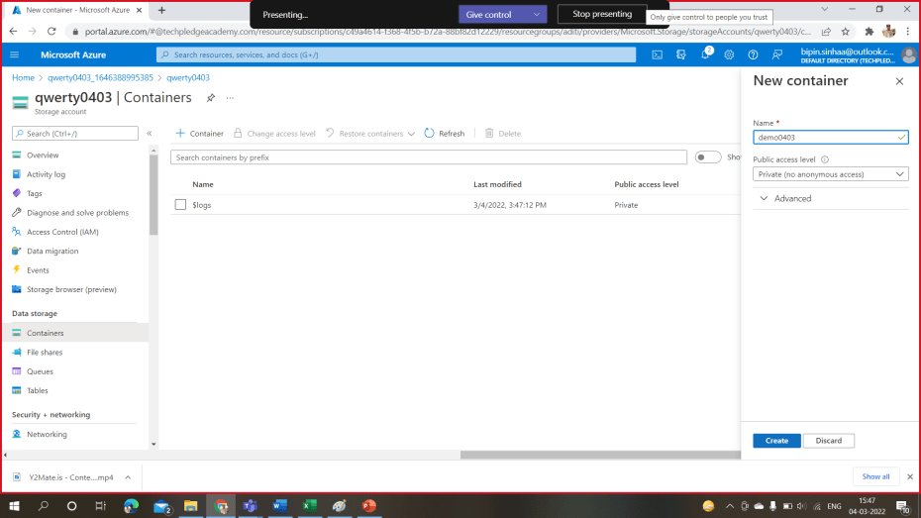

**Step-4**

Once you create the container upload an image in container.

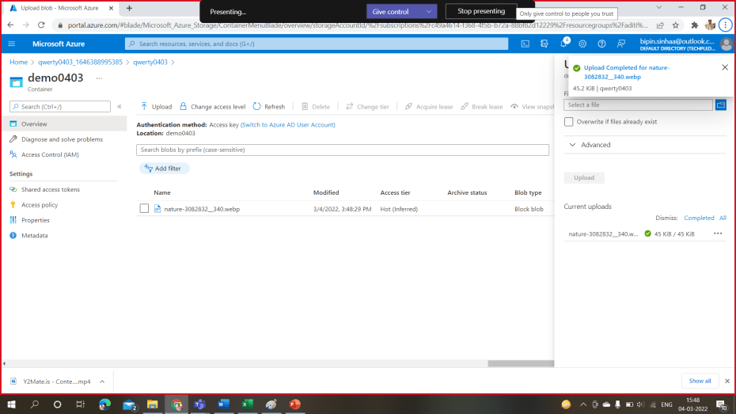

**Step-5**

Now click on the image a there will be a URL. Open this image on the new tab and there will be an error message that will appear. This message shows because your container is still not publicly visible. EG:-

[https://qwerty0403.blob.core.windows.net/demo0403/nature-3082832__340.webp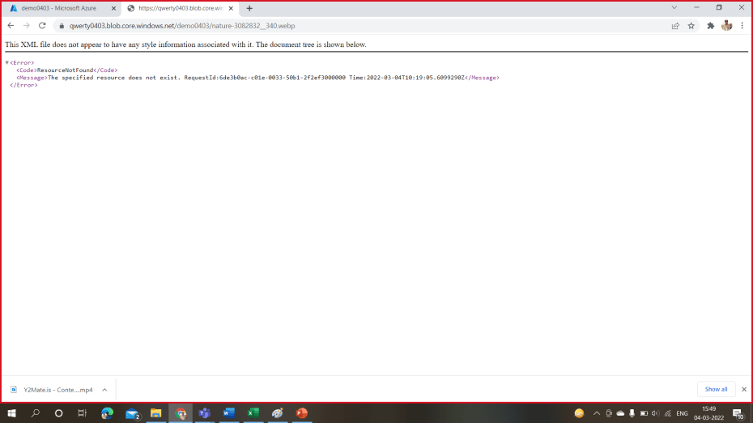](https://qwerty0403.blob.core.windows.net/demo0403/nature-3082832__340.webp)

**Step-6**

So to make your container and the image publicly visible, change the access level. Click on access level and change it to **“Container (anonymous read access for containers and blobs)”**.

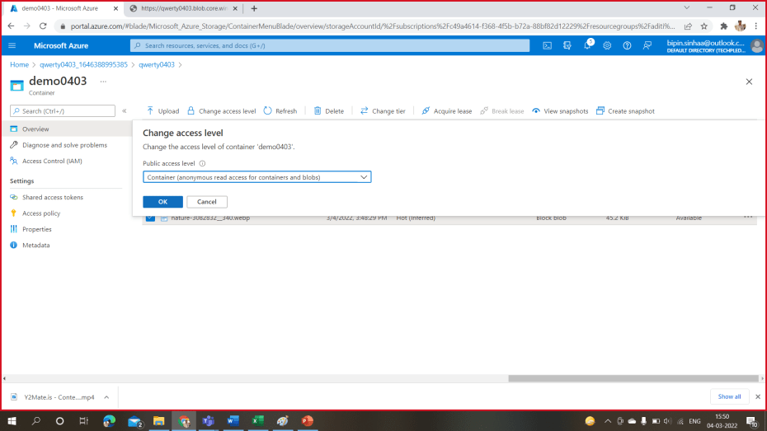

**Step-7**

Now open the link again. Now the image will be visible.

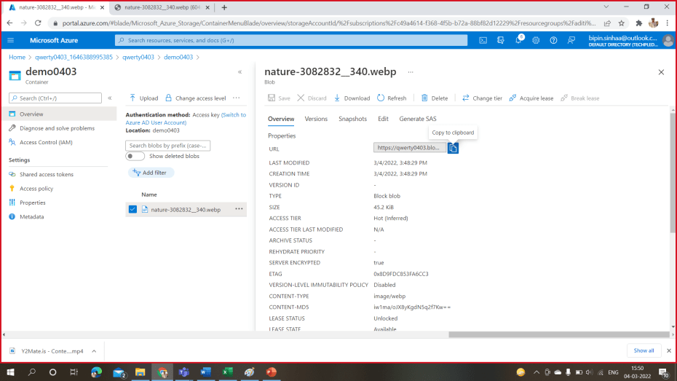

**Step-8**

Now on the left menu under **Data management** click on **Static website.** Enable to static website as show in the figure.

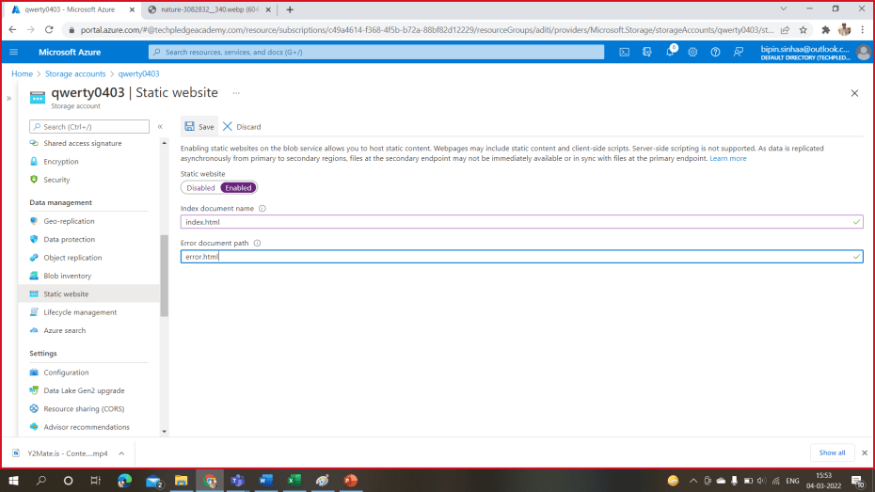

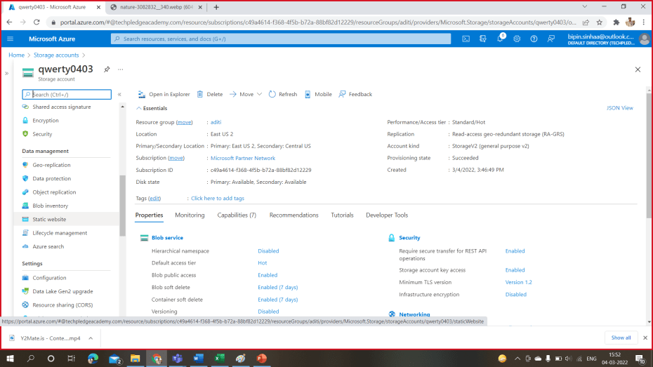

**Step-9**

After enabling Static Website now navigate to **Azure CDN** on the left menu. Now create a new CDN. Follow the steps as mentioned in the image. Click on **create.** It may take 2 hrs to get created. So wait……Do not close.

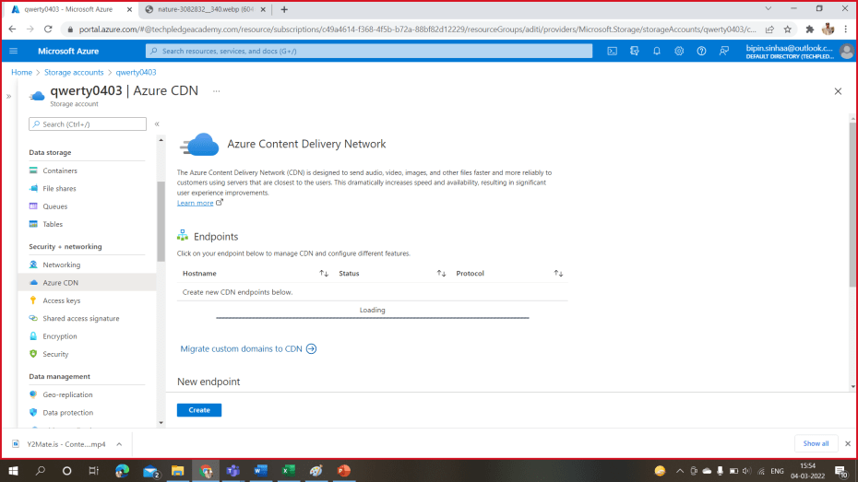

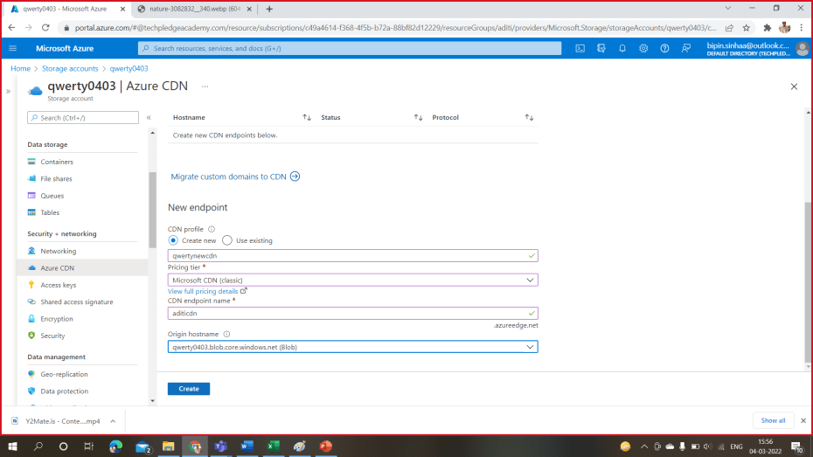

**Step-10**

Now once your CDN is created copy the end point on a new tab. You will observe that the image will open much faster than what it opens on normal container.

You have successfully created a CDN connection.

